Directions to the Exchange
- From new street station find the bull pictured below
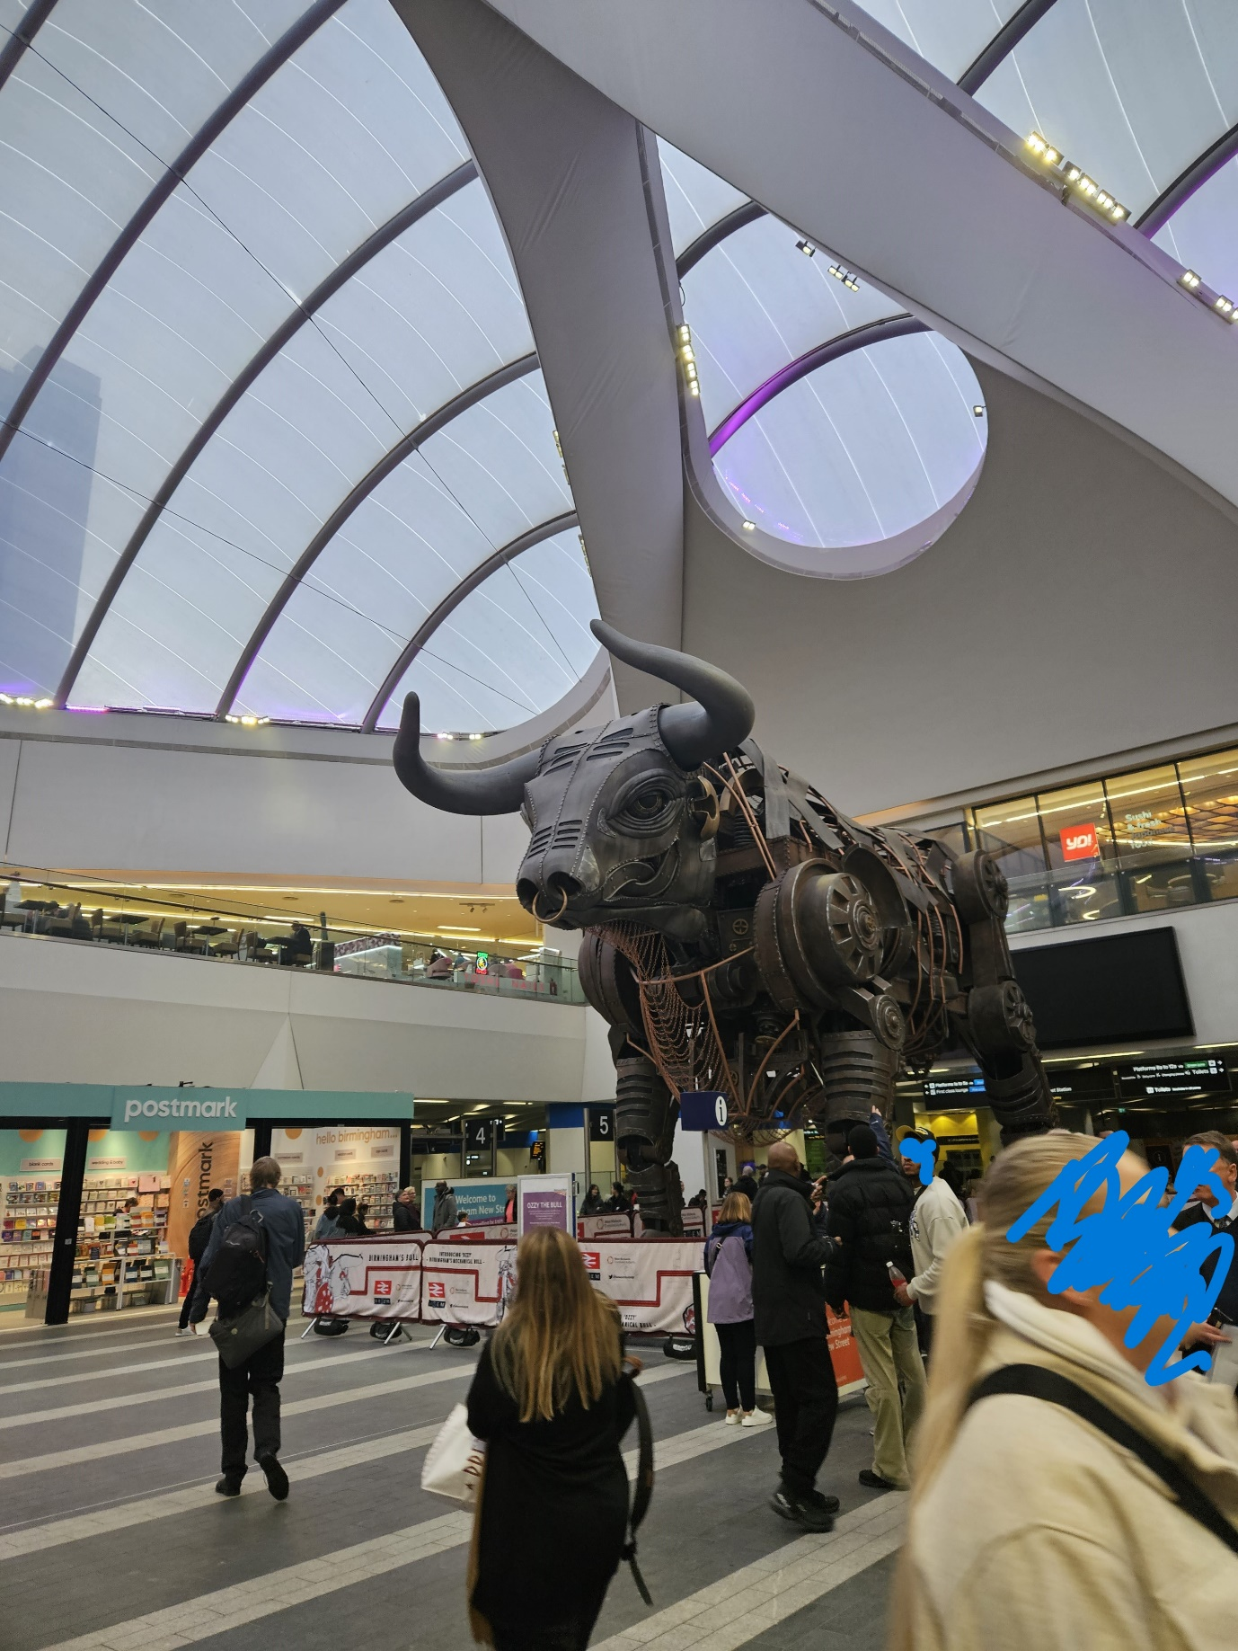
- Carry on towards the Stephenson street Exit.

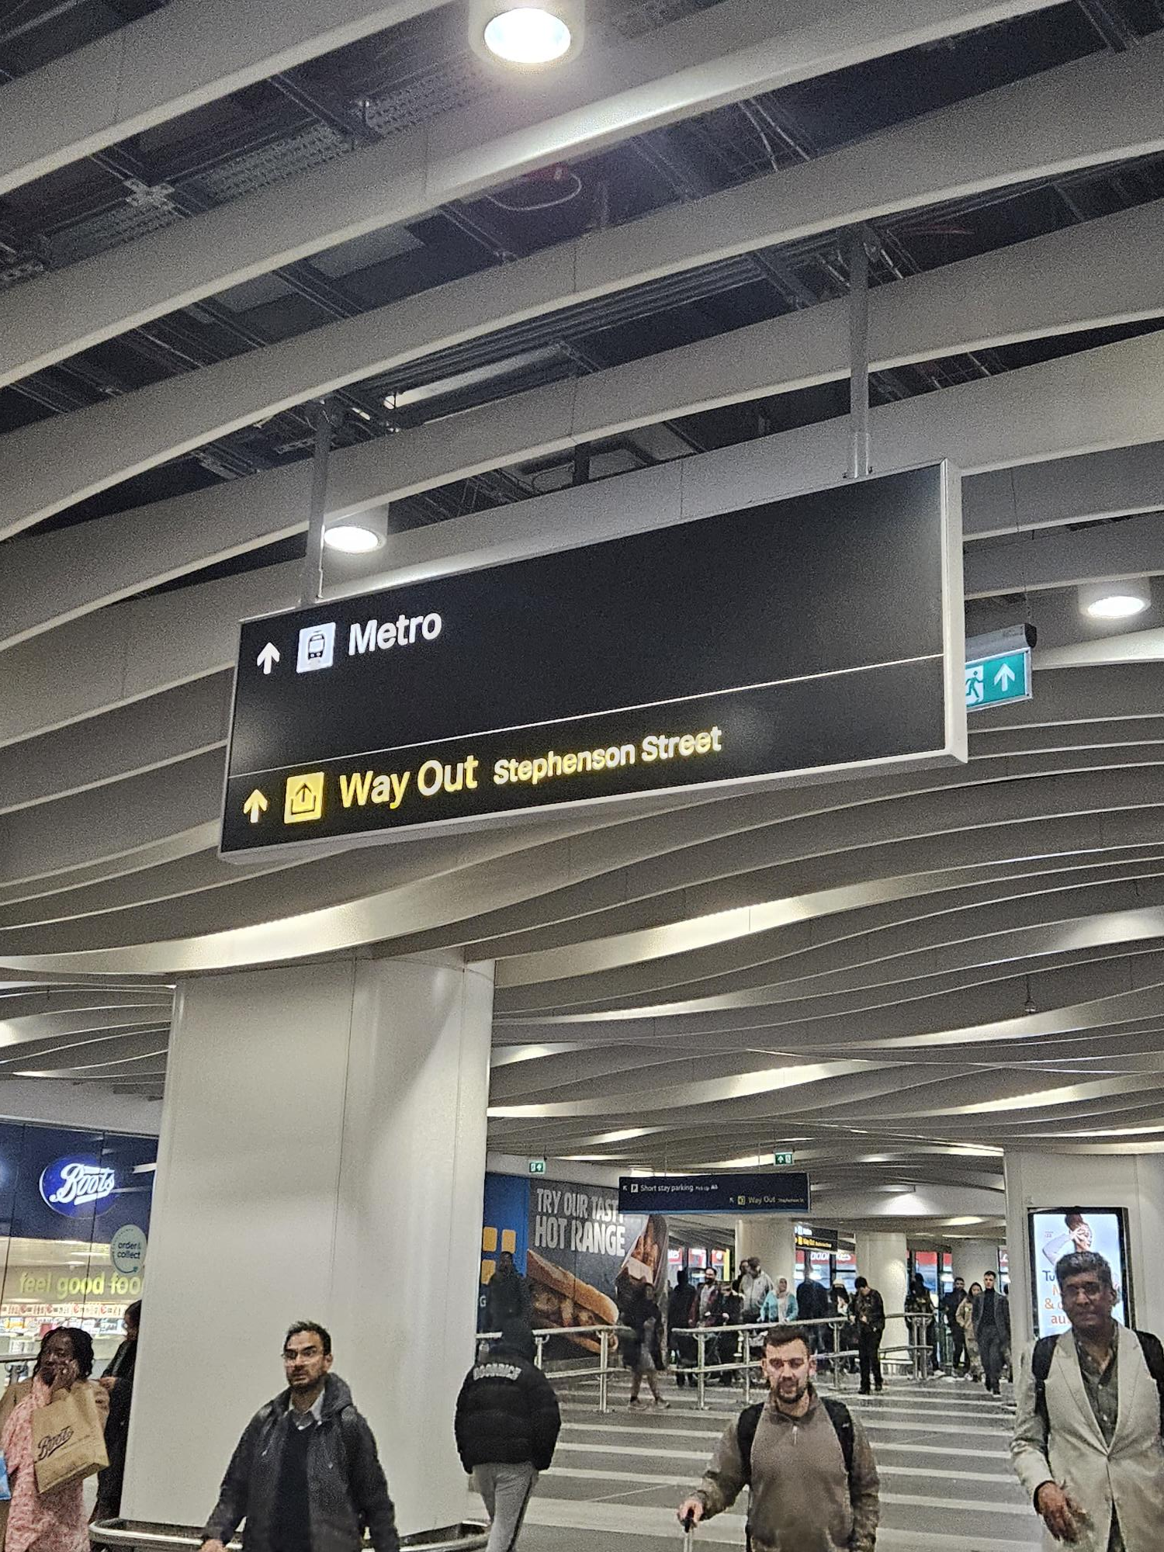

- You will see archies upon exit of the train station.
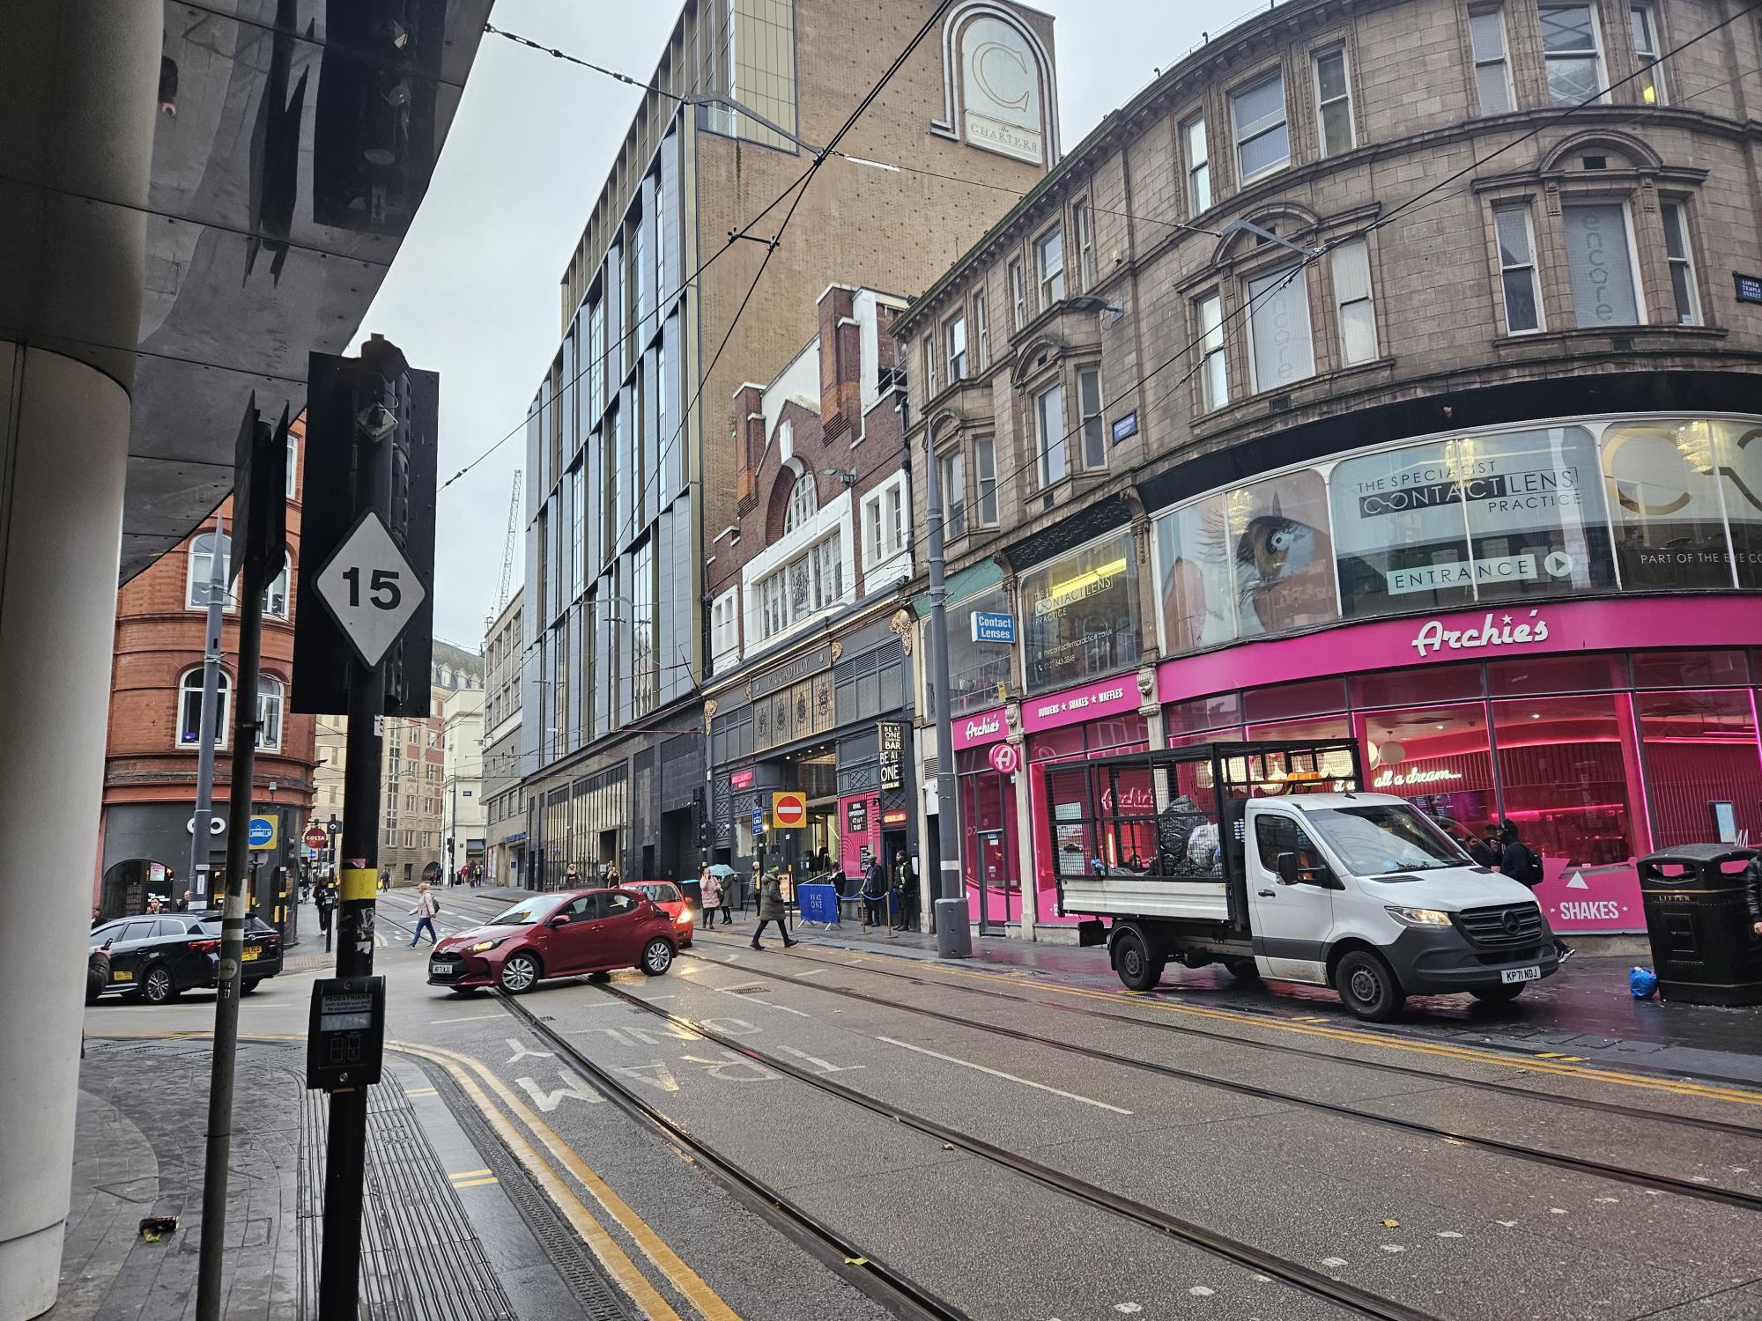

- Take a left out of the station and walk along Stephenson street past costa.
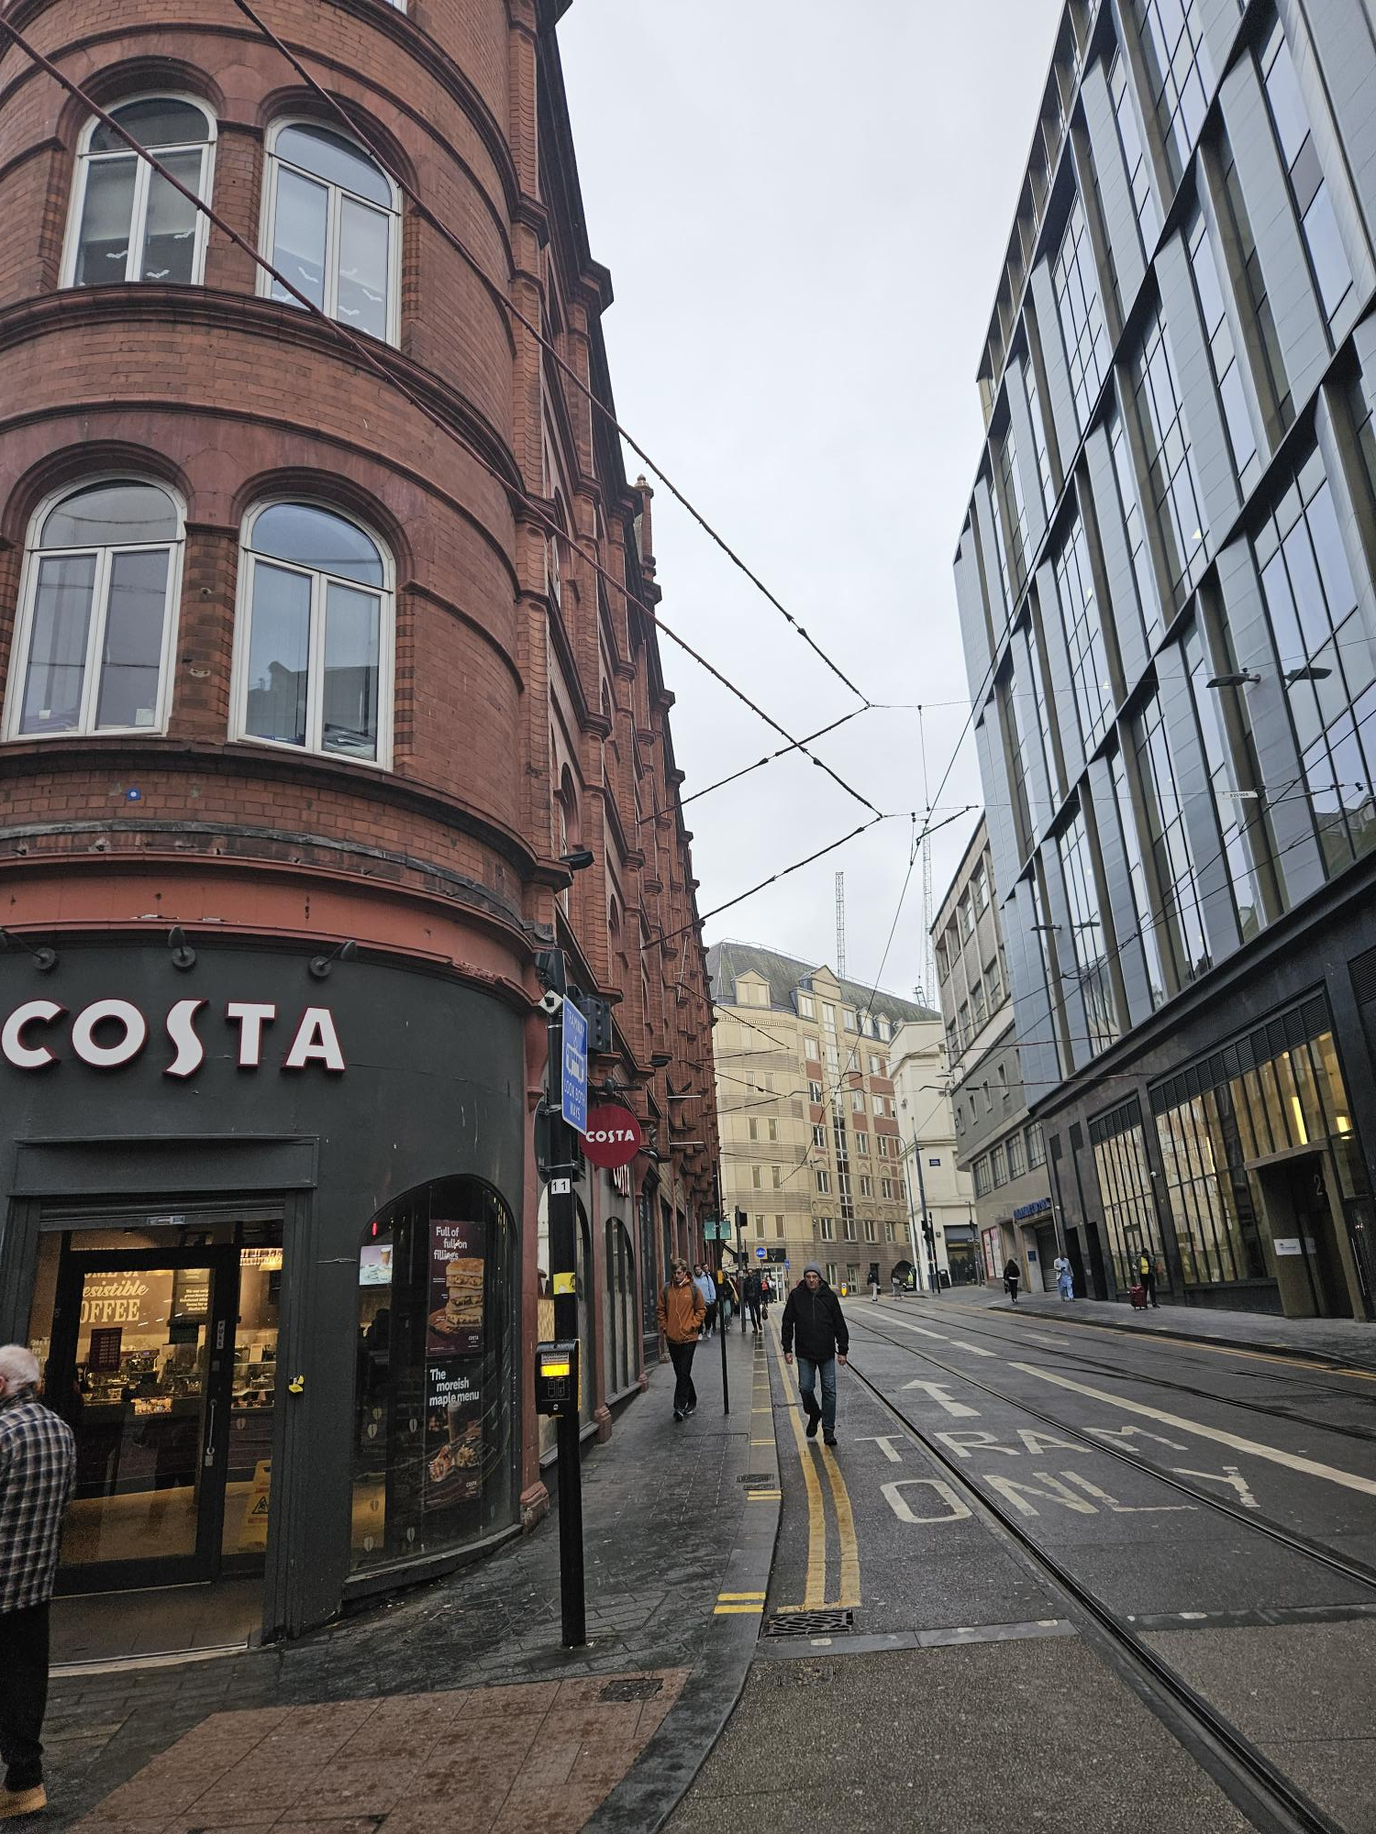
- Continue up and around the corner towards the Town Hall.
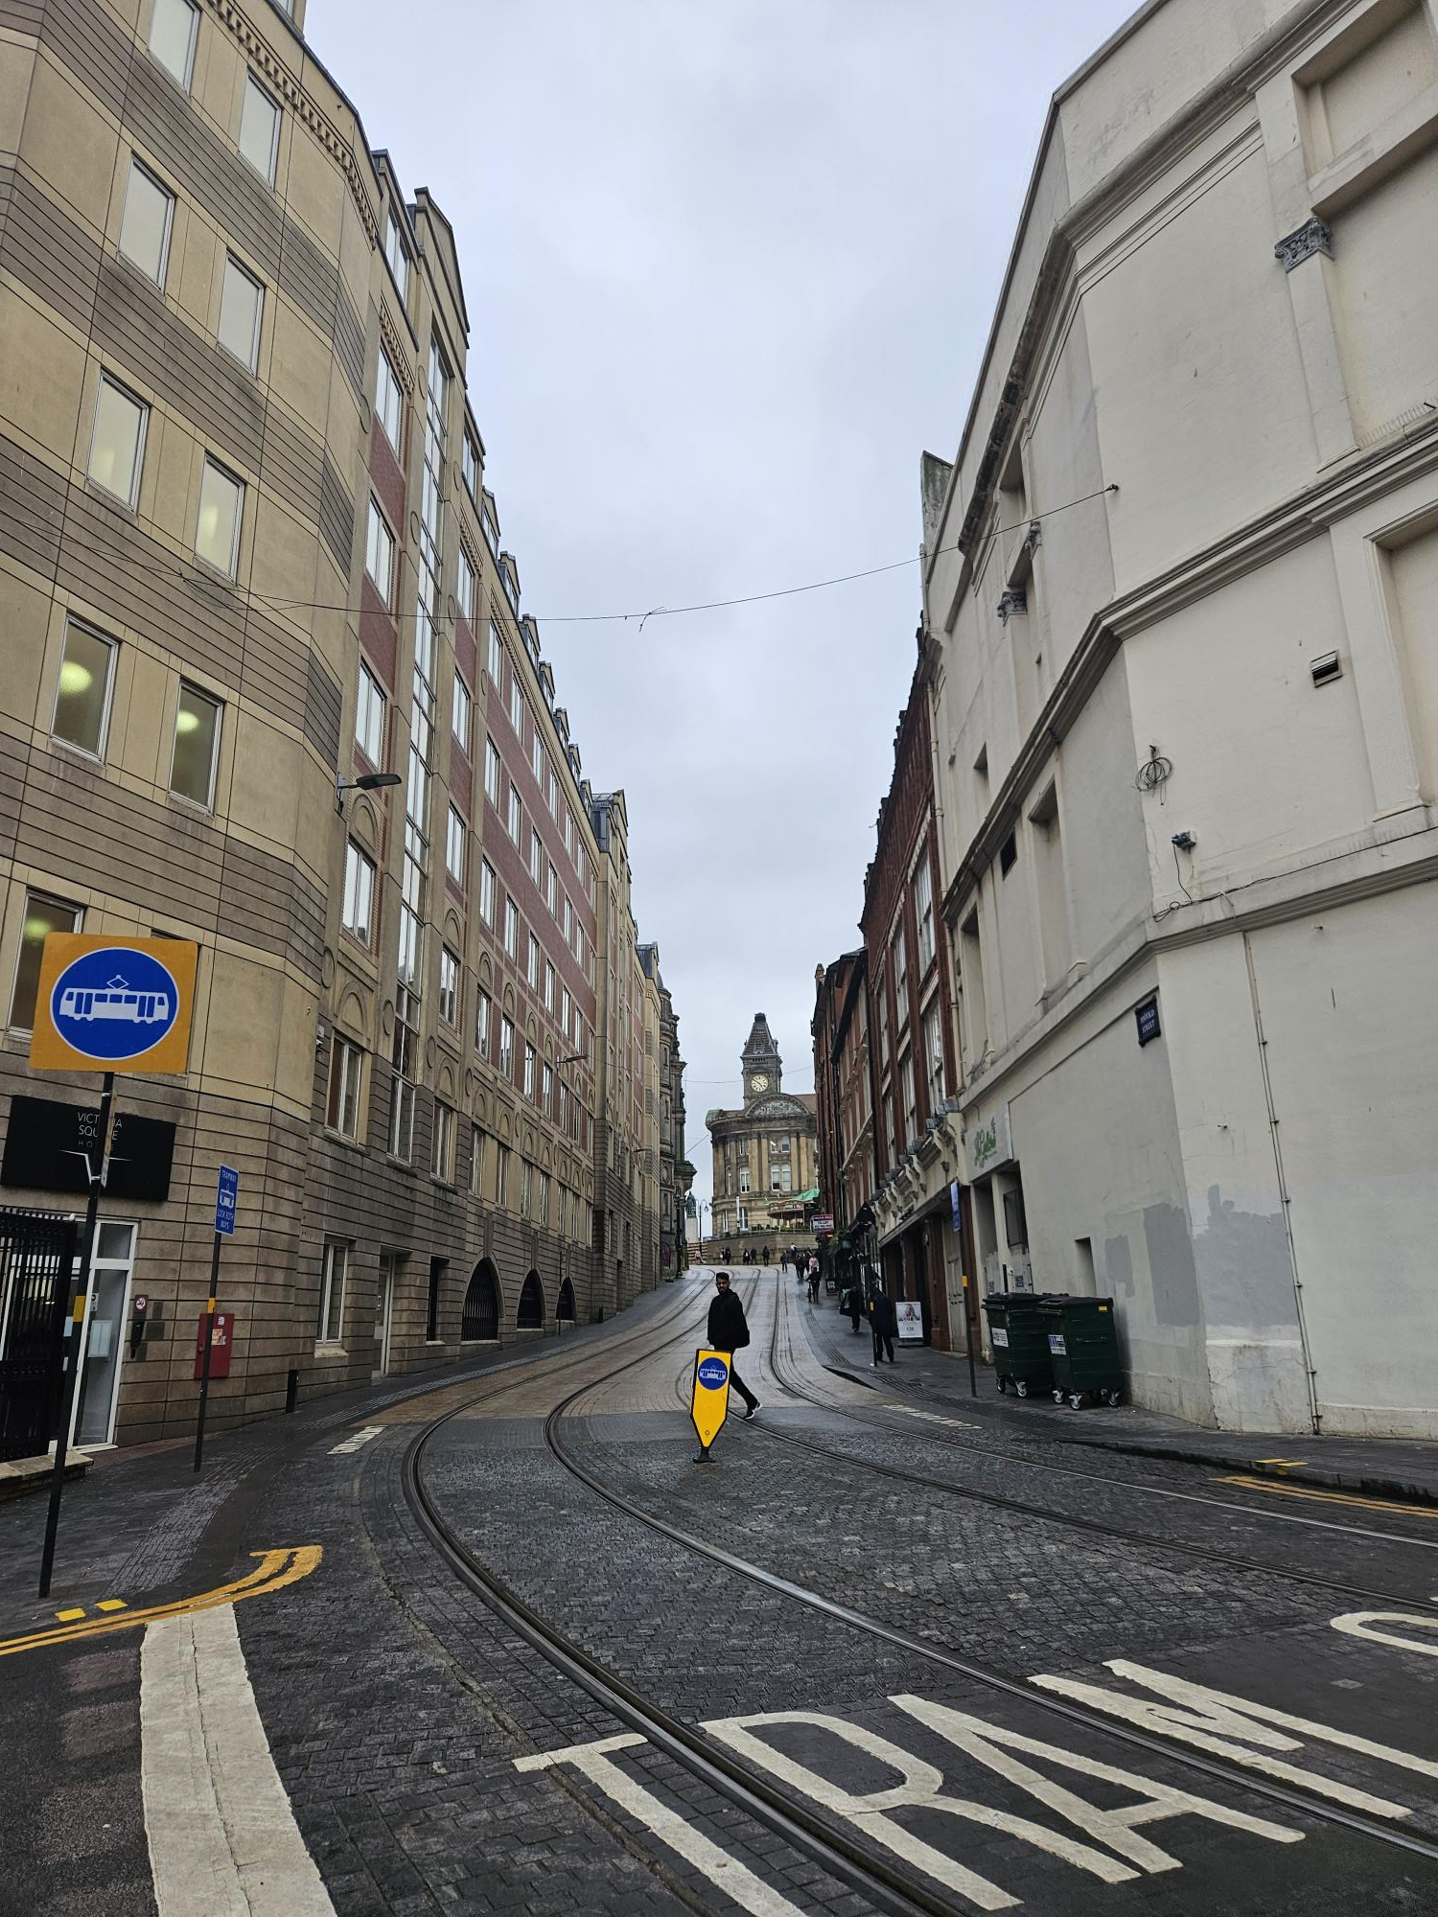

- Cross the road and tram lines and walk straight up past the statue.
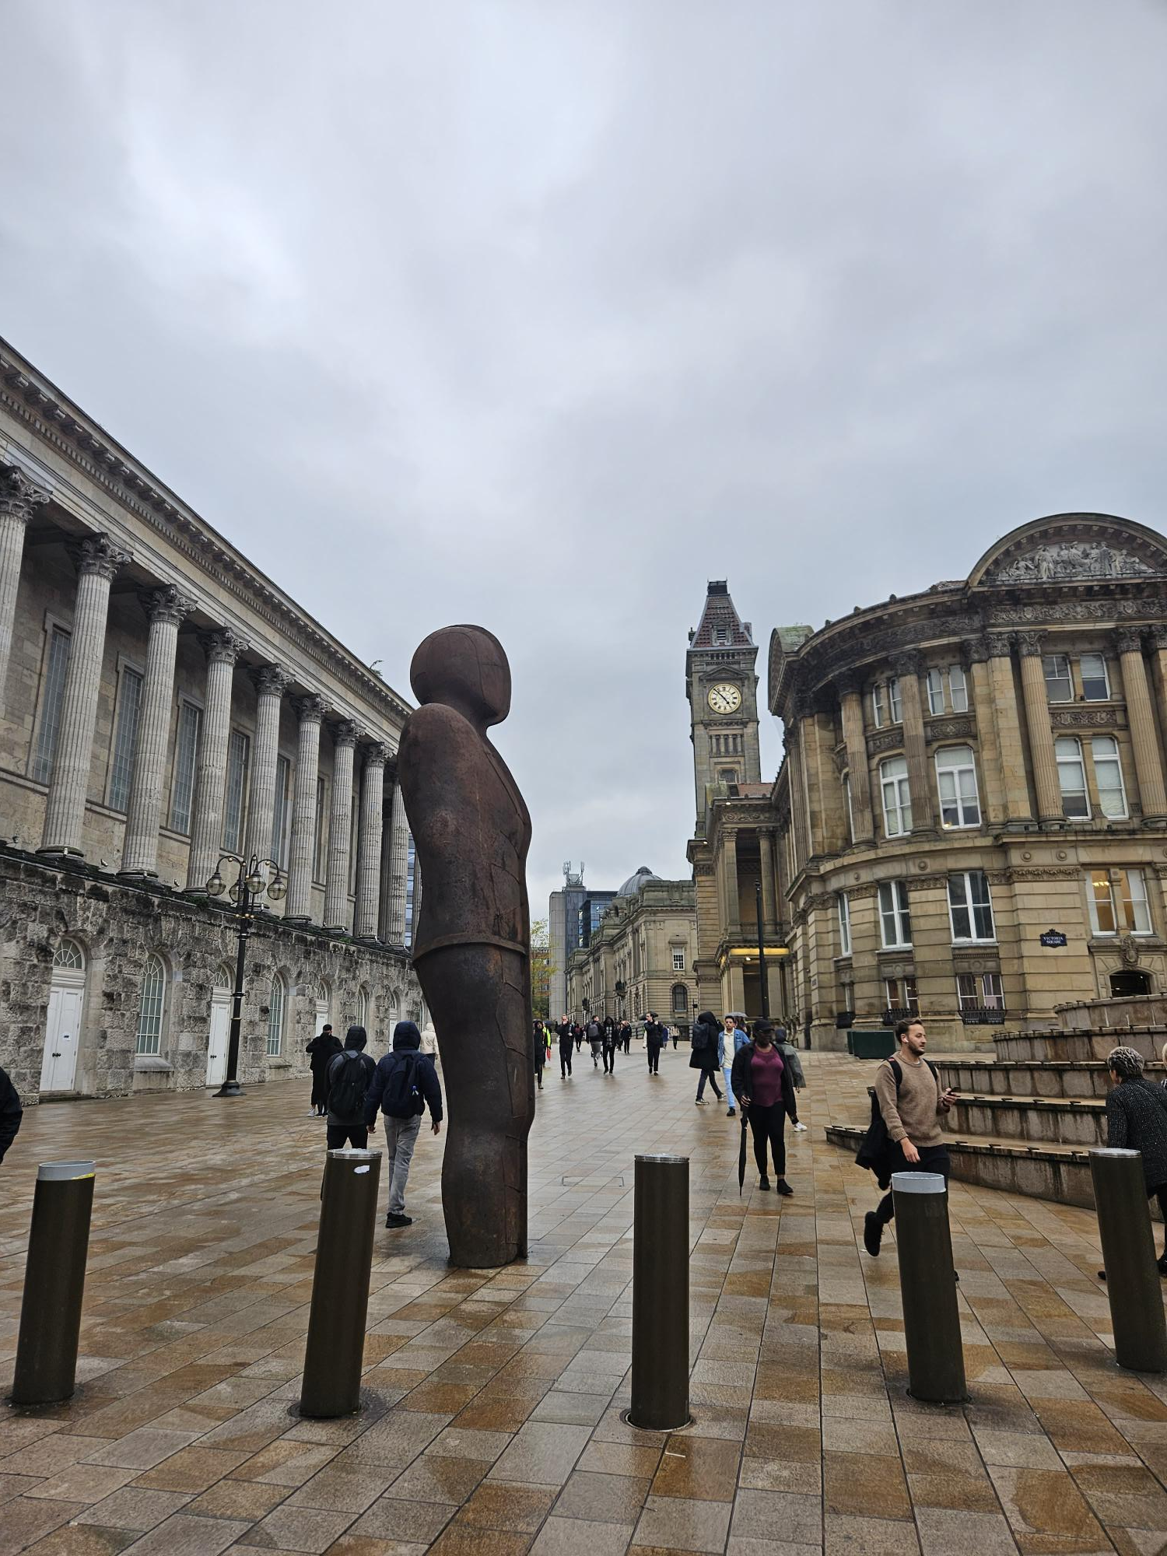

- You will reach a white fountain. Climb the stairs and turn left.
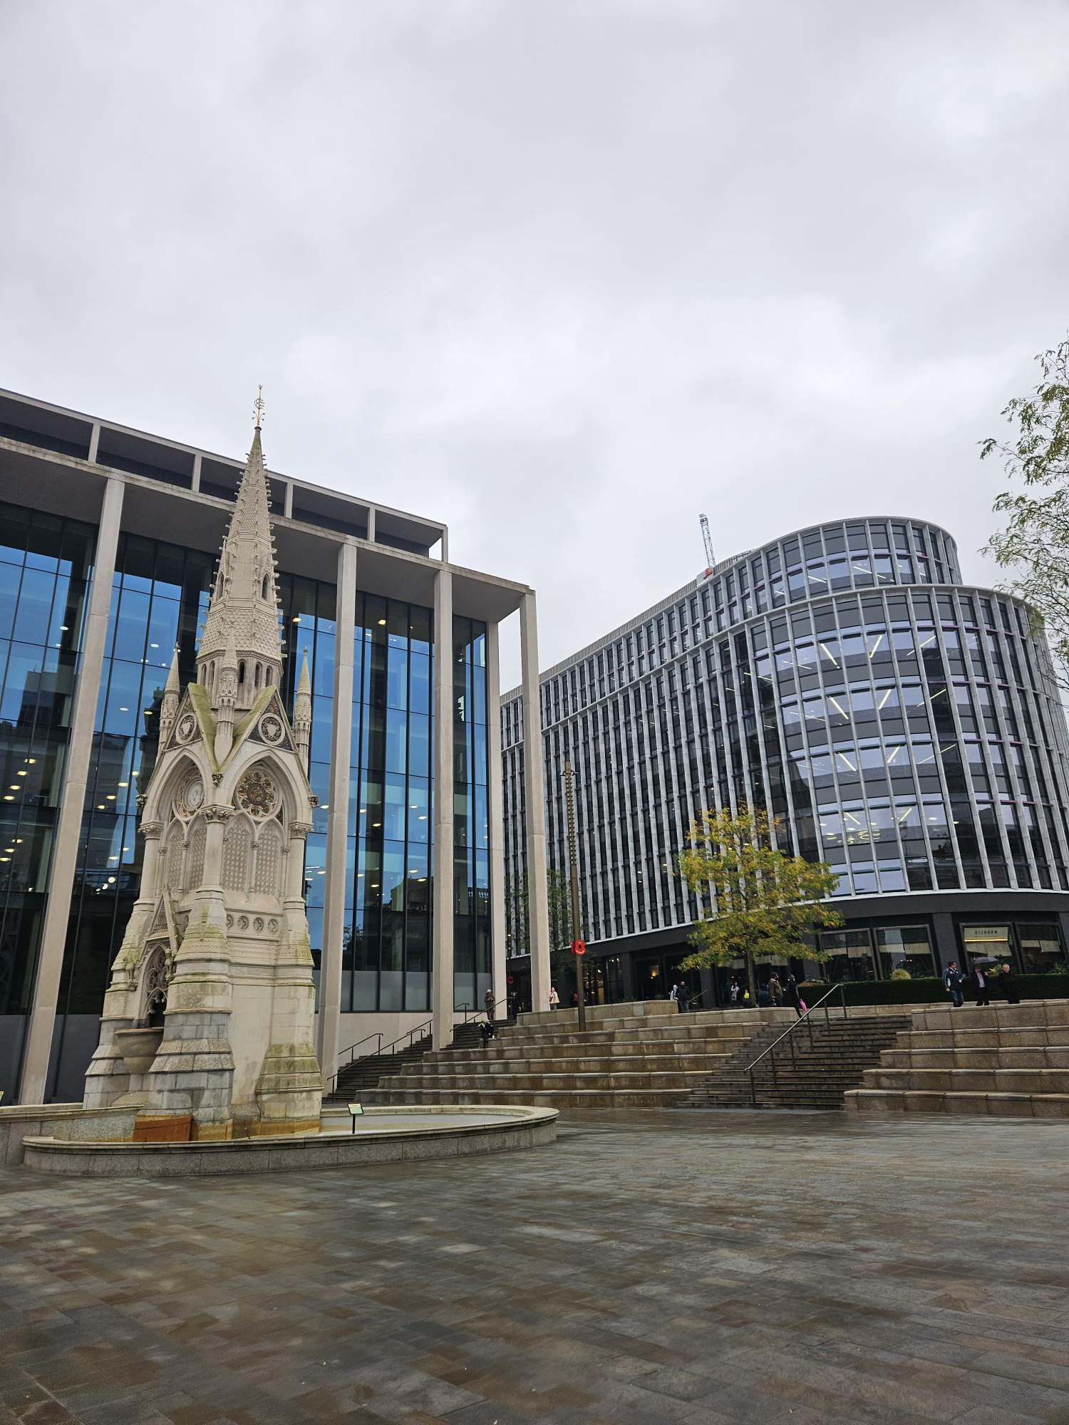
- Walk down Chamberlain Square keeping Dishoom and Albert’s Schloss on your right.
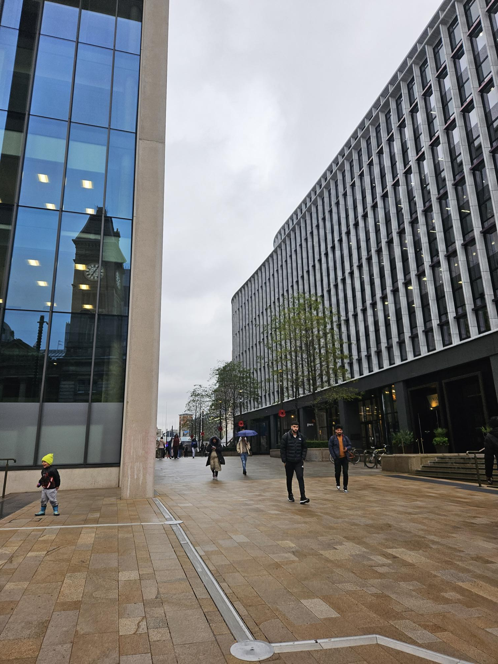

- Keep walking until you see Birmingham Library on your right.
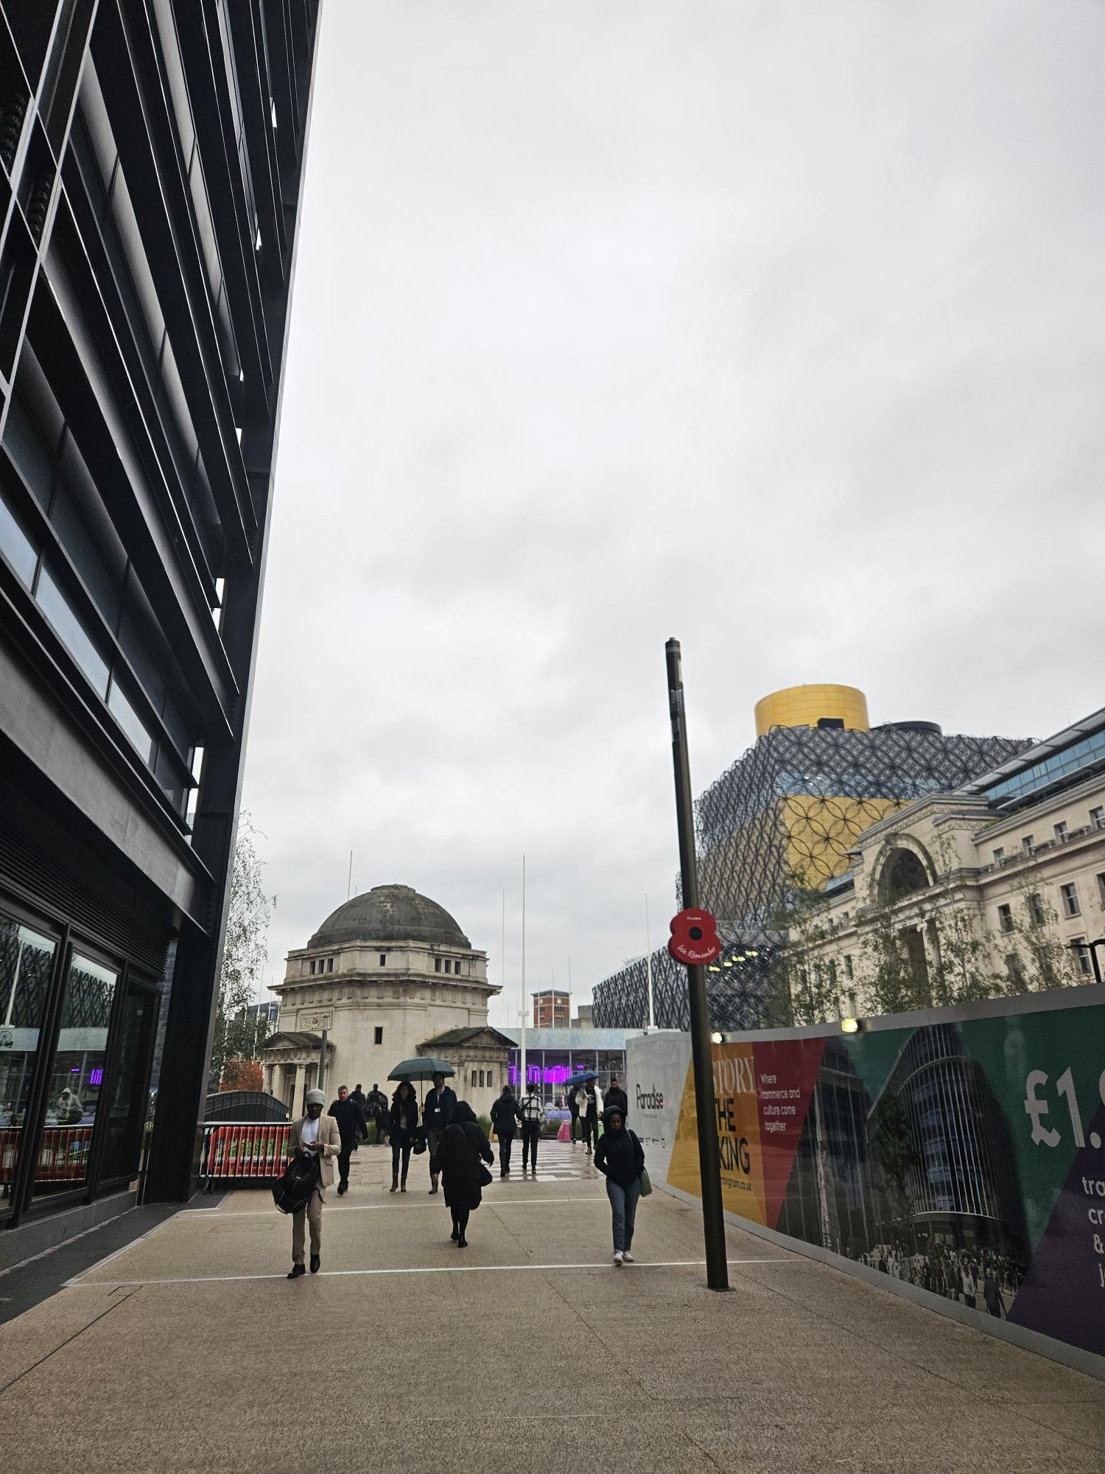

- Walk on the left of the white memorial building (pictured below)
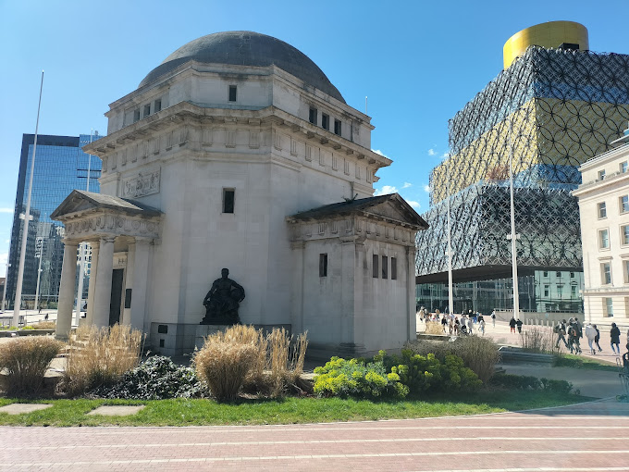

- Cross the road and the tram lines and you will arrive at the Exchange (on the right of HSBC). Follow signs to the Assembly room on the 2nd floor. Register and grab a hot drink before the day starts!
