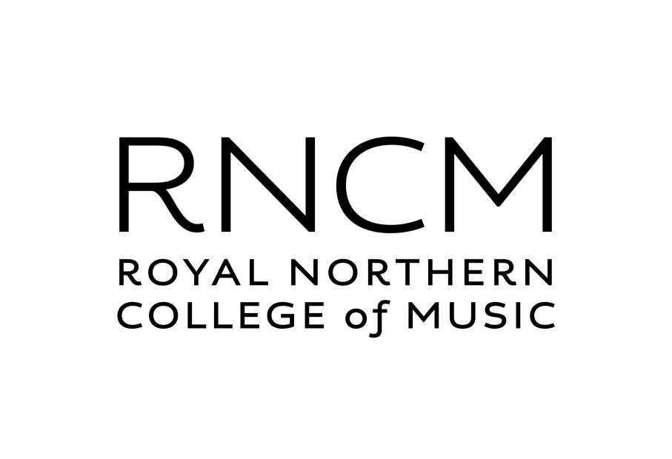
BMSS43 EXHIBITOR INFORMATION

43rd BMSS ANNUAL MEETING & EXHIBITION
Royal Northern College of Music, 12th – 14th September 2023
EXHIBITOR INFORMATION

MEETING LOCATION:
The Royal Northern College of Music (RNCM), 124 Oxford Road, Manchester, M13 9RD, UK. (Tel: 0161 907 5200, www.rncm.ac.uk). A map showing the location of the RNCM is available below (Appendix 1).

VENDOR EXHIBITION:
The vendor exhibition will be located in the concourse of the RNCM building. A plan of the exhibition layout is available below (Appendix 2). The RNCM concourse is adjacent to the college foyer, where delegate registration will take place. Lunches and morning/afternoon refreshments will be served in the RNCM concourse, from three food/beverage service points distributed within the exhibition area. There are a number of time slots scheduled in the scientific programme to allow delegates ample opportunity to visit the vendor exhibition, Social Evening (Tuesday 12th September, 19:00-23:00), and refreshment & lunch breaks (Wednesday 13th September and Thursday 14th September).
There is no afternoon tea break on the final day of the meeting (Thursday 14th September).

EXHIBITION SET UP/BREAK DOWN:
Exhibitors may set up their exhibits in the RNCM concourse between 09:00 and 18:00 on Tuesday 12th September and/or between 08:00 and 10:00 on Wednesday 13th September (prior to the morning refreshment break). Breakdown may commence after 15:00 on Thursday 14th September.
Set up must be suspended prior to the start of the welcome mixer (Tuesday 12th at 19:00).

Exhibitors are responsible for transporting all of their exhibit material to and from the venue. There is limited storage capacity to facilitate shipping of material in advance of the meeting (or hold material for delayed return shipment after the meeting). If such deliveries/collections are required, they will only be accepted from Monday 11th September 2023 onwards. Exhibitors should liaise directly with the RNCM conferencing team regarding advanced delivery and/or deferred return shipment (BMSS personnel will only be on site from Monday 11th - Thursday 14th September 2023).

Material for the conference can be sent in advance to arrive on Monday 11th September ONLY to the Royal Northern College of Music. Goods are stored at the company's own risk. All deliveries must be labelled as follows:

BMSS 2023
[Name of Exhibitor]
F.A.O. Joanne Dooley
Royal Northern College of Music (RNCM)
124 Oxford Road
Manchester M13 9RD
United Kingdom

RNCM CONFERENCE & CATERING TEAM:
Head of Conference & Catering: Joanne Dooley
[T]: +44 (0) 161 907 5248 [E]: joanne.dooley@rncm.ac.uk [W]: www.rncm.ac.uk

SELF-DRIVE DELIVERIES [12th SEPTEMBER 2023]:
Exhibitors wishing to unload their self-drive cars/vans on Tuesday should access the rear of the RNCM via the Rosamond Street West entrance to the RNCM service yard.
Access to the RNCM service yard is for the loading and unloading of vehicles only.
Exhibitors must park their vehicles in a public car park (Appendix 1).

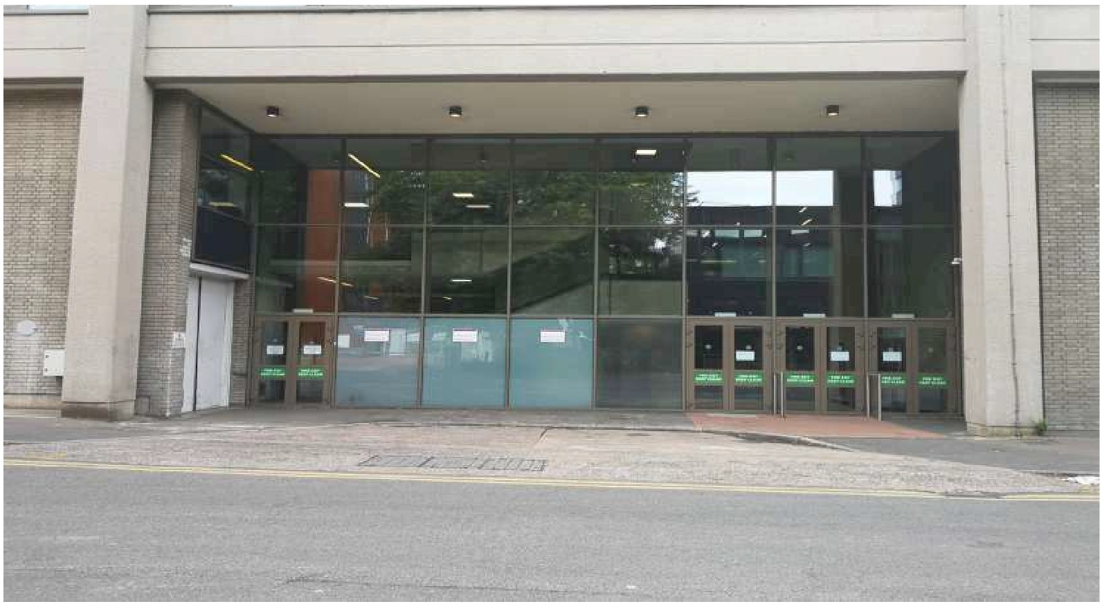

The loading bay will be allocated on a first-come-first-served basis. Please be patient while queueing, turn off your engines while waiting and off-load your equipment efficiently to ease congestion.

COLLECTIONS
Please ensure items to be collected are removed by Friday 15th September at the latest. Please provide information i.e. when you depart, please let the venue know if you plan to leave any equipment/stands to be collected later that day or the next day - you will be instructed where to leave these. Please clearly label any items to be collected along with the delivery address and name of the company picking up the item. Please let the venue know when they will be collected. A storage charge will apply for items not collected on time and we cannot accept any responsibility for material left on the premises.

EXHIBITION FURNITURE & POWER:
- Each Exhibitor will be allocated a 6ft trestle table, two chairs and a tablecloth (double/triple/quadruple plots include this furniture pro rata).
Each of the spaces available has two 13 A electricity sockets for the exhibitor to use. Please make us aware of any equipment that may not be suitable for this or will require a higher-than-average electricity supply.
Exhibitors are advised to bring 240V extension leads to ensure optimum power access.
- It is a health and safety requirement that all electrical items are PAT tested and that any trailing cables are covered using a suitable cable cover. Please bring your own covers or other equipment needed to make your cabling tidy and prevent trip hazards.
- Please make us aware if you are planning to bring in any large or unusual items as part of your exhibition.
- Banners must be no wider than the space allocated and must not obstruct walkways.
- Each exhibitor is responsible for keeping their stand clean and tidy. All packaging and boxes will need to be kept out of sight in storage and cleared away after the event has taken place.
- Please note that exhibitors are not permitted to stick any materials to the walls, the pillars or the windows anywhere within the building.

Exhibitors that do not require their default allocation of furniture should inform the BMSS Meetings Secretary by Friday 1st September 2023.

FULL REGISTRATION BADGE & EXHIBITION PASS ACCESS:
As advertised, each exhibition plot booking includes two complimentary full conference registrations (multiple plot bookings include full complimentary registrations pro rata). These entitle exhibitors to attend all scientific and social sessions, except the conference dinner on Wednesday. The delegate registration badges that form part of your company’s exhibition package will be issued in the name of your company and made available for collection at the Registration Desk.

CONFERENCE DINNER:
The conference dinner (Wednesday 13th September, 20:00) will be held in the International Suite of the Mercure Hotel, Portland Street, Manchester, M1 4PH (Appendix 3). Dinner will be preceded by a drinks reception starting at 19:00pm at the Mercure.
Sponsors’ & Exhibitors’ representatives wishing to attend the conference dinner and drinksreception are required to purchase a ticket (on-line) for the event in advance.

SCIENTIFIC PROGRAMME & ABSTRACTS:
The full scientific programme and E-Abstract Book (password protected) will be available for download prior to the start of the meeting on the BMSS43 event website. (43rd BMSS Annual Meeting | BMSS)

WIFI:
Free WiFi is available within the RNCM through the Cloud. To gain access exhibitors and delegates need to set up a wifi account, which can be done in advance, using an email address and creating a password.

ACCOMMODATION:
Accommodation is not included. The 43rd BMSS Annual Meeting coincides with several other major conferences in Manchester. Consequently, hotel accommodation is anticipated to be at a premium. The BMSS, through its exclusive accommodation partner HelmsBriscoe, have secured a range of hotel rooms at preferential rates for delegates and exhibitors. Accommodation details and prices are available on the BMSS website.

PUBLIC PARKING:
Please refer to Appendix 1 for details of local car parking.

BMSS EXHIBITION MANAGEMENT/VENDOR SUPPORT
BMSS Meetings Secretary: Lindsay Harding
[T]: +44 (0) 1484 256899* [E]: meetingssec@bmss.org.uk
[M]: +44 (0) 7395 262441
BMSS Administrator: Lisa Sage
[T]: +44 (0) 160 681 0562* [E]: admin@bmss.org.uk
[M]: +44 (0) 758 2213034
* These numbers will NOT be staffed after Friday 8th September 2023.

APPENDIX 1: BMS43 CONFERENCE VENUE
The Royal Northern College of Music (RNCM) 124 Oxford Road, Manchester, M13 9RD, UK.
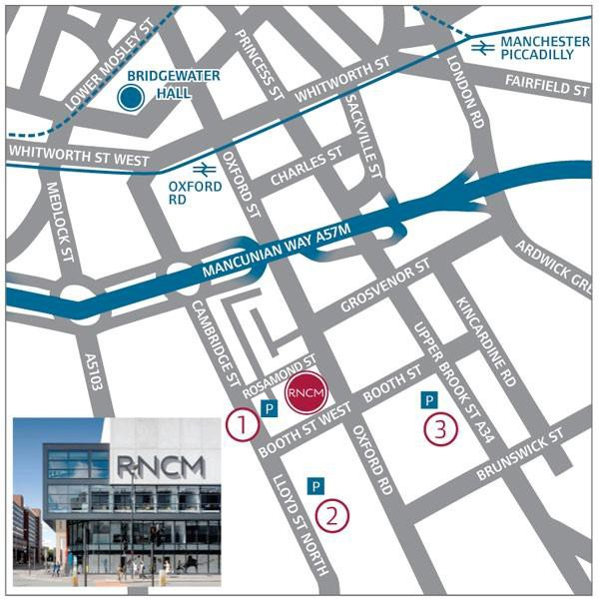

PUBLIC PARKING
The University of Manchester (Multi-storey)
Booth St West
Manchester M13 9GR
Open 7 days per week
For current charges and times please visit The University of Manchester parking website

APCOA Car park (Multi-storey)
Manchester Aquatic Centre
Booth Street East
Manchester M13 9SS
Open 7 days per week
For current charges and times please visit the APCOA website

APPENDIX 2: BMSS43 EXHIBITION PLAN

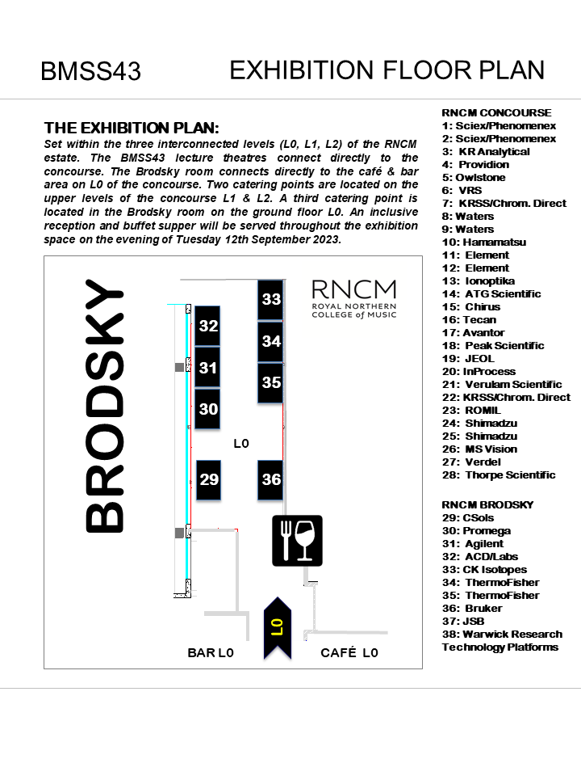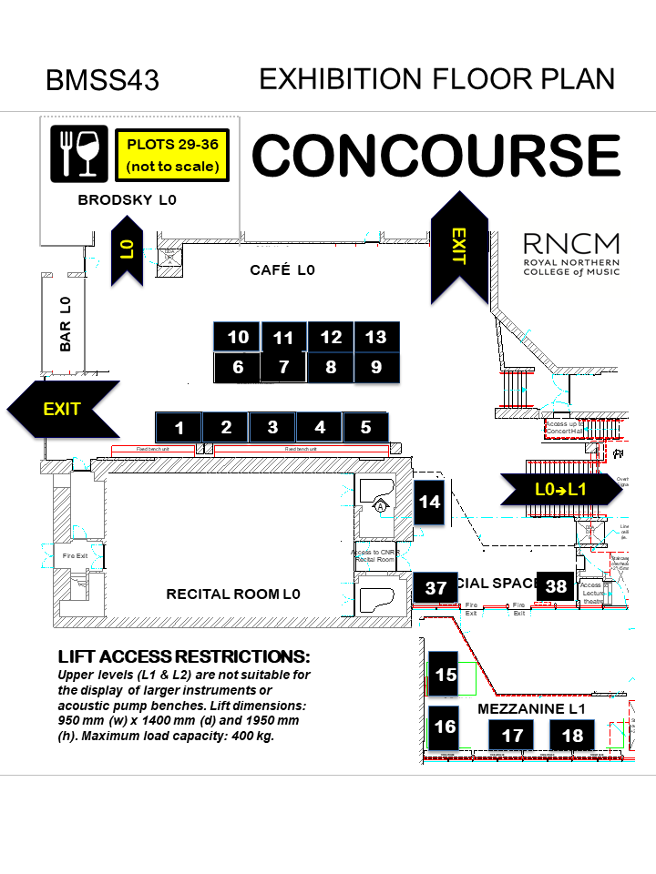

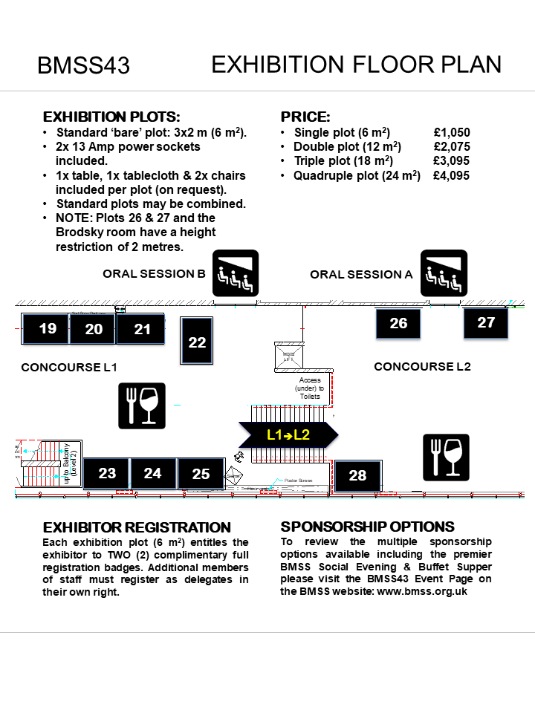

APPENDIX 3: BMSS43 CONFERENCE DINNER
International Suite, Mercure Hotel, Portland Street, Manchester M1 4PH.

