LGBTQ+ & Friends ‘Get-Together’
Manchester 13the September 2023

The BMSS warmly welcome LGBTQ+ delegates and friends to join us for an informal get-together at Yates Manchester at 18:00 on Wednesday 14th September, prior to the BMSS43 conference dinner.

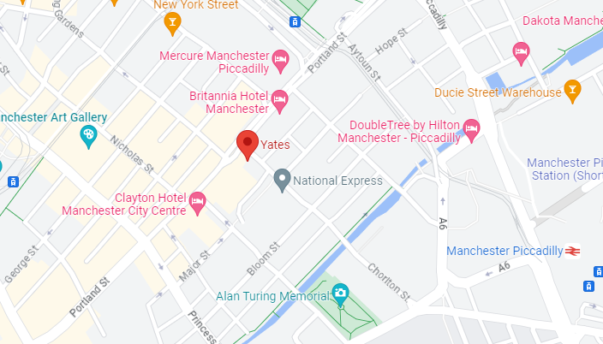
Yates, 49 Portland St, Manchester M1 3LA

